# Part A: Loan Function

For Part A, you are to complete Worksheet A, which will calculate how much total interest you are to pay for certain interest rates and certain term periods.

You will use the PMT function in Excel (use help to learn about this function). Here are some hints for the parameters:

* **Rate** – this is the monthly rate (need to divide the annual rate by 12)
* **Nper** – number of total payments made over lifetime of loan
* **Pv** – the amount of money borrowed
* **Fv , Type** – these are optional – please omit these

The loan amount will be in one of the cells (use that cell within your formulas). Assume that the cash value at the end of the payback period is zero and the payment is due at the end of each month (hence not needing to have Fv and Type values as parameters).

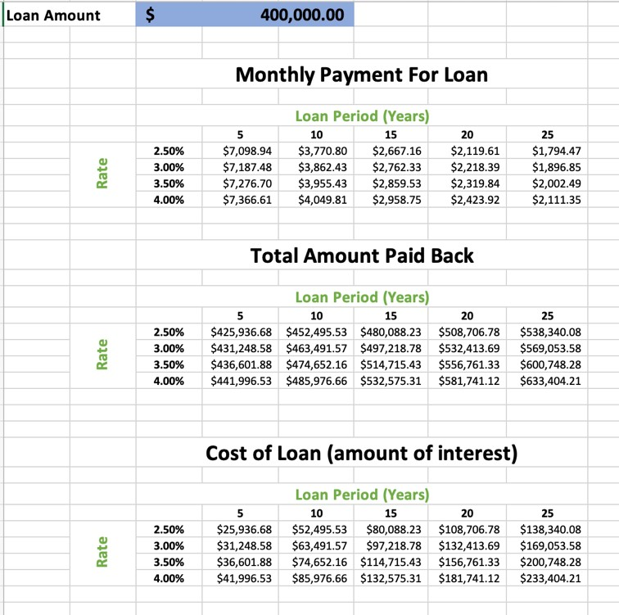

The above three tables show a loan of $400,000, over a period of 25 years at rates of 2.5 to 4.0%. Looking at the table, we can see that:

Borrowing $400,000, with repayment over 25 years, and an annual interest rate of 3.5% =

$2002.49 / mth repayment & we would pay $200,748.28 in interest over the 25 years

If the interest rate dropped ½ percent to 3.0%,

$1,896.85/ mth & we would ‘only’ pay $169,053.58 in interest over the 25 years

* The first table will display the monthly loan repayment amounts. The columns will be the payback period and the rows will be the interest rates. (use the PMT function in each cell in the table, using the row heading and column headings as parameters in the function)

* The second table will be the total amount paid back over the length of the loan (in other words - the loan amount plus the interest). Use the same headings as the first table and use the data from the first table in your formulas (ie – monthly payment [loan entry] * number of monthly payments).

* The third table will calculate the cost of the loan (ie – the total amount paid back [table B entry] minus the original amount of the loan [Loan Amount entry])

Format the tables so that the tables look presentable (ie - table headings, not all of the numbers are negative numbers, etc). Clue – multiplying a negative number by -1 will result in a positive value.

Display the tables in your workbook so that it corresponds to a loan of $450,000, interest rates from 2.5% to 4.0% (in 0.5% increments) and term periods from 5 year to 25 years (in 5 year increments).

# Part B: Marks Worksheets

For Part B you are to modify the worksheets in Excel that helps you keep track of the marks of a fictitious class.

Part B will consist of three sheets:

1. a *marks* worksheet (similar to Figure B-1) – *PT B - Marks*
2. a *marking scheme* worksheet (similar to Figure B-2) – *PT B - MS*
3. *class list* worksheet (initial data) – *PT B – Class List*

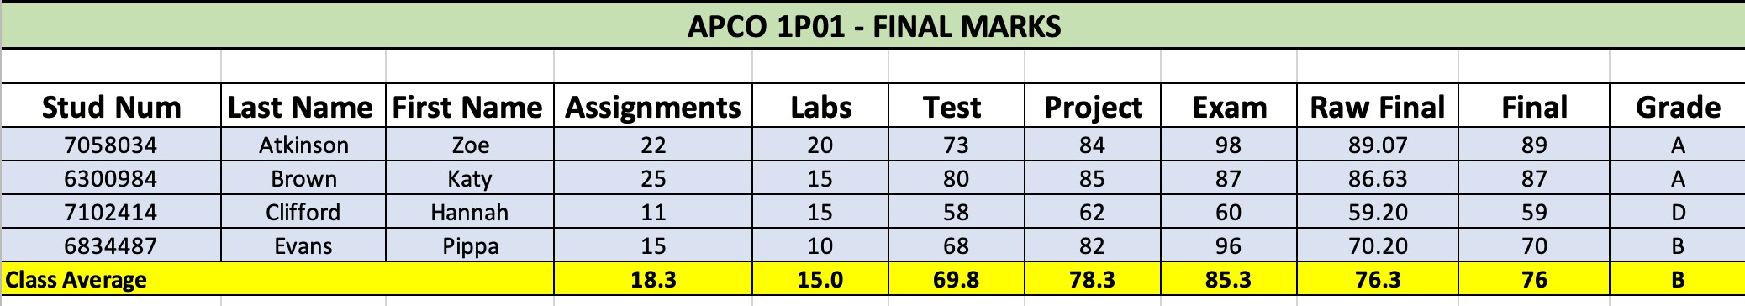 **Fig B-1**

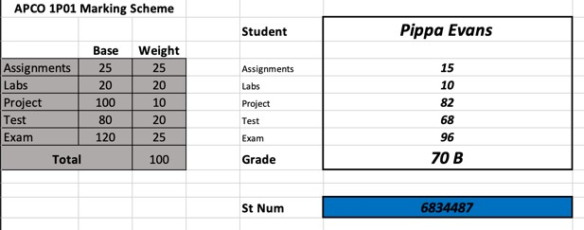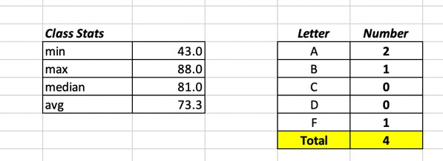

**Fig B-2**  **Fig B-3**

In the *PT B – Class List* worksheet, notice that the Test column is blank. In Column J, generate random numbers between 45 and 80. Copy just the values (not the formulas) into Column F. This simulates the students getting a mark on the test out of 80.

For the *PT B - MS* worksheet, similar to Figure B-2, the section on the right will allow the professor to type in a student number (where it is highlighted in blue) and it will then display above inside the thick box - the student name, their marks for the 5 pieces of work as well as the student’s final mark and letter grade. If it is an invalid student number, N/A will appear in all the columns.

To do this you will need to use the VLOOKUP function multiple times:

=VLOOKUP(lookup value, table array, index_num, [range lookup]) hint – use a value of false for range lookup. The mark and letter grade will be a VLOOKUP of two different columns and use the CONCATENATE function.

The class list is sorted by Student Number. Your PT B - Marks worksheet, will sort the class by Last Name and then First Name (since two of the students have the same last name).

**Formulas:**

Raw Final Mark

* calculated by using the student's marks on the first worksheet and the marking scheme on the second worksheet
* for each piece of work, you need to calculate what it contributes to the final mark and add it to the running total for all pieces of work to get a final mark. o For example – if a student got 50 / 80 on the test, and the test was worth 20% of the final mark, then the test would contribute 50/80*20 = 12.5 marks toward the final mark.
* **the calculation of the raw final mark needs to only include cell references (and not hard coded numbers) \*\*\*\*\***

Final Mark

* round the Raw Final Mark to the closest whole number
* need to format the cells (or use a round function)

Grade

* assign a letter based on the final mark (>79 = A, >69 = B, >59 = C, >49 = D, else it is an F)
* use an IF statement (use the nested logic that we discussed in the online videos)

Averages –

* average of each piece of work, the raw final mark, the final mark and the grade

Class Summary –

* similar to Fig B-3, put below on your worksheet with the student’s marks
* before grades can be finalized, the chair of the department may wish to know how the class did. To that end, the class’s lowest (**min**), highest (**max**), and average (both **median** and **mean**) grades can be easily calculated.

# Part C: Analyze Stats

Part C will consist of 2 worksheets:

*PT C – Top 50 NHL* worksheet that will answer 10 questions based on the data that is found on *the* worksheet. You can use the COUNTIFS, SUMIFS functions, and other functions that your feel are appropriate.

As well, on the *PT C – Analysis* worksheet you will insert 3 charts highlighting information that you choose that is found on *PT C – Top 50 NHL* worksheet. For example – you could have a 2D Column chart, a Histogram, and a 2D Pie Chart. Please have appropriate titles, legends, titles on each axis (if applicable) and present the data in an attractive manner